Regional Child youth

and family Conference
Day 1

8:30 am Registration
9:00 am Opening and Welcome to Country
9:10 am Speaker: Pam Barker – CEO Yfoundations
Plenary & presentation
10:00 am Speaker: Nate Ahoy - MadProppaDeadly
Music and young people
11:00 am Morning Tea
11:30 am Speaker: TBC
TBC
12:30 pm Q & A Panel with Day 1 speakers
1:00 pm Lunch
1:45pm Workshops
TBC

3:00 pm Break and workshop change over
3:15 pm Workshops
See above for content
5:00 pm Close

Regional Child youth

and family Conference
Day 2

8:30 am Registration
9:00 am Opening and Welcome
9:10 am Speaker: StandBy: Support After Suicide
Supporting Children and Young People impacted by suicide
10:05 am Speaker: TBC
TBC
11:00 am Morning Tea
11:30 am Speaker: Pam Barker – CEO Yfoundations
To Be Advised.
12:30 pm Q & A Panel with Day 2 speakers
1:00 pm Lunch
1:45 pm Workshops
TBC

StandBy - Resources and activities for Supporting Children and Young People impacted by suicide

3:00 pm Break and workshop change over
3:15 pm Workshops
See above for content
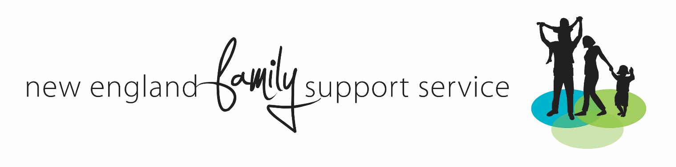
5:00 pm Wrap up and Thank you

